2026/27
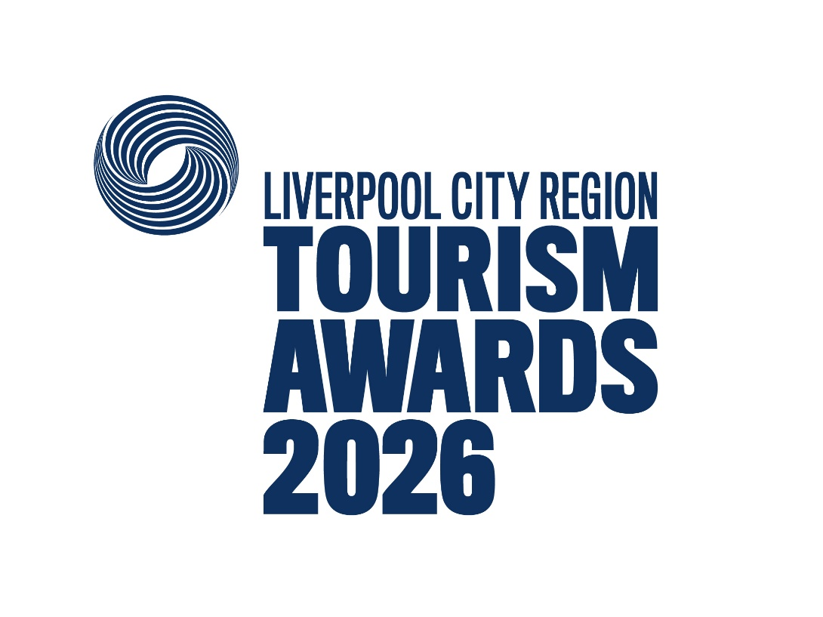

Experience of the Year

Recognises providers of memorable and immersive activities for visitors to participate in, from cooking masterclasses to woodland nature tours.

This sample application form is for information only and all applications must be made via the online application system.

Useful information before you start your application.

Before you start your application:
- Read and accept the Applicant Terms and Conditions when prompted.

- Make sure that you are eligible for the category you are considering applying for.
Read the eligibility criteria carefully, if you are deemed ineligible you may be moved to another category where you would be eligible, or your application may be discounted altogether. If you are not sure whether you are eligible, check with the competition organiser before completing your application.

- To avoid duplication in your responses, read all the questions before you start. For most categories each question covers a different aspect of your business, e.g.
  - Question 1 – Top Qualities
e.g. unique selling points, strengths and the essence of the business
  - Question 2 – Recent Improvements
e.g. business developments and improvements over the last two years
  - Question 3 – Results
e.g. recent successes from across the business – providing figures where relevant
  - Question 4 – Future Plans
e.g. plans to develop and promote the business over the next year

- Read the guidance information starting ‘judges will be looking for . . .’ for suggestions on what to include in your answers.

- By setting up an account you can save your work and come back to it later – you don’t have to start and submit your application in one sitting.
- Take your time but be mindful of the closing date for applications.

- Be aware of the word limits, they are exact. We would recommend you use the full word count where possible.

- Proof your entry before submitting.

Good luck!

Eligibility criteria

- Directly involved in tourism, making a contribution to the visitor economy with a significant proportion of business generated by people visiting from outside the local area.

- The application must relate to one named experience or experience type only - e.g. mountain biking experiences, gin masterclasses
- For businesses that offer multiple experiences, you are invited to submit an application that relates to only one experience, or experience type (ideally your ‘hero’ or most popular experience or experience type).
(Any award must then be associated with this one experience or experience type).
- Any visitor experience that requires participation in an activity
- The experience may involve a host/teacher/instructor/guide or may be undertaken independently
- Likely to be immersive and interactive
- Typically experiences will be learning, adventure or relaxation based
- Likely to fall under one of these themes:
  - Wellness and well-being (e.g. spa)
  - Sporting and active (e.g. caving)
  - Environment (e.g. beach cleaning, dry stone walling)
  - Arts & culture (e.g. guided tours, pottery making)
  - Culinary (e.g. cookery courses)
- Food service experiences are not eligible for this category and should consider the Taste of England Award category, which assesses the quality of food and drink served to the visitor.
- An experience located at a visitor attraction may only apply to this category if it can be booked separately from the main attraction and can be accessed without the need to pay for or visit the main attraction e.g. the Bombay Sapphire Distillery is eligible to apply for the Large Visitor Attraction of the Year category, which includes its ‘Discovery Experience’ as part of the standard admission ticket (therefore it would not be eligible for this category), but they could enter their ‘Gin Cocktail Masterclass’ within the Experience of the Year category as this is a separate experience not available to all visitors.
- For another example, an outdoor activity centre (like Go Ape) providing a selection of separately booked high ropes experiences can enter their ‘hero’ or most popular experience (Treetop Challenge) as one application.
- A boat tour business (like Serenity Farne Island Boat Tours) providing a selection of separately booked boat tours can enter their ‘hero’ or most popular experience (Holy Island Trip) as one application.
- The experience must be open to the public/ non-residents – i.e. participation is not restricted to residents, unless residency/ over-night accommodation is part of the itinerary for the named experience

- Businesses that serve food must have a minimum food hygiene rating of four out of five. The competition organisers reserve the right to refuse an application if this minimum requirement is not met at any point prior to the awards ceremony. An exception is made for new businesses who have not yet been graded.

- The named experience must be taking place during the published judging dates and must occur on a regular and ongoing basis. One-off or short-term experiences are classed as events and festival, and as such, are not eligible to apply to this category

- Businesses of all sizes can apply as this category is judged within the context and style of the business.

- Businesses that have been trading for at least three months and up to two years when applications open are strongly recommended to apply to the New Tourism Business of the Year category before considering applying to any other categories
  - For the purpose of eligibility for this competition, ‘trading’ means serving customers. If the business has not been trading this long, then they will need to wait to apply to the competition in 2027/28

Applicant & business details
(not scored)

Applicant’s name:

Enter the applicant’s name here.

Applicant’s job title:

Enter the applicant’s job title here.

Applicant’s phone number:

Enter the applicant’s phone number here.

Applicant’s email:

Enter applicant’s email here.

Business name:
Name of business application relates to. Give the name used to promote the business, as you wish it to appear in all publicity materials, on certificates, in presentations etc.

Enter your business name here.

Business address:

Enter your business address here.

Closures during judging period 1st October 2026 – 27th November 2026:

Enter closures during the judging period here.

Age of business

For businesses trading for less than two years, what exact date did the business relating to this application start trading?
For businesses trading for more than two years, what year did the business relating to this application start trading?
Note: For the purposes of eligibility 'trading' means serving customers.

No of staff
Enter the number of staff employed (full time equivalent) here.

Enter the number of staff here.

Promotional Description
Provide a promotional description of your business.
• Focus on its strengths and stand out features
• Write your description with regard to this category
• This wording will be used in PR and awards literature
• Wording provided is subject to edit
• 120 words maximum

Enter the promotional description here.

Promotional Images
Provide up to three high resolution photos.
• Photos should relate to this category
• Photos should not be edited in any way e.g. embedded text or logos, a collage
• Only include photos that you own the copyright for
• If the photo requires a credit e.g. photographer, please provide details
• These photos will be used in PR and awards literature

Background
(not scored)

Briefly outline the story of your business (250 words maximum).
For example:
• Length of time business has been trading and time under current ownership
• Target market(s) and typical customer profile
• Key milestones in developing the business
• Indication of size of business
• Number of staff employed, if any

Enter information on the background of your business here.

List any awards, ratings and accolades received in the last two years. Include the title, awarding body, level and date achieved.
For example:
• Successes in this competition and the VisitEngland Awards for Excellence
• TripAdvisor Traveller's Choice Award
• Green Tourism award
• VisitEngland quality assessment, local quality accreditation

Enter information on any awards, ratings or accolades here.

There is no requirement for your business to be quality assessed. However, if you have an independent quality assessment/mystery shopping report from the last two years, you might wish to upload it here (optional).

Enter information on any quality assessments here.

Online presence & reviews
(this section is 30% of the final score)
- Social Media & Website = 20%
- Online Reviews = 10%

Provide links to your online presence, which will be reviewed and scored by judges in addition to your answers to the four questions. Other sites may also be checked.
As part of this review, judges will be looking for evidence of your commitment to Accessible and Inclusive Tourism as well as Regenerative Tourism.

Enter the website URL here.

Accessibility & inclusivity information
Provide links to your accessibility and inclusivity information.

Enter the accessibility & inclusivity information URL here.

If information on your approach to accessibility and inclusivity is not available online, outline the details here (max. 300 words)

Enter the accessibility & inclusivity information here.

Regenerative Tourism information
Regenerative Tourism champions that tourism should leave a place better than it was before. The main goal is for visitors to have a positive impact in the destination or place they visit. Through this we wish to champion actions of suppliers, staff and local stakeholders in supporting the entrant on their delivery to the visitor.
We are looking for actions that support some or all of the below to a standard that could inspire visitors, suppliers and staff in positive actions:
- Climate – actions to decarbonise energy/mobility towards Net Zero
- Circular Economy – clear examples of management of suppliers, waste, recycling, sustainable products and efficient use of resources
- Biodiversity – actions to protect and restore nature
- Place based – respect for local area/communities, tourism that does no harm
Provide links to your regenerative tourism information.

Enter the regenerative tourism information URL here.

If information on your approach to regenerative tourism is not available online, outline the details here (max. 300 words)

Enter the regenerative tourism information here.

Provide links to all business pages/profiles on Facebook, Instagram and X, LinkedIn and TikTok etc.

Enter the social media URL here.

Online review sites
Provide specific links to customer review listings for your business e.g. TripAdvisor, Facebook, Booking.com, Google, Euan’s Guide, UpFront Reviews

Enter the online review URL here.

Question 1 - Your Top Qualities
(this question is 20% of the final score)

Tell us about up to five ways in which your experience is impressive compared to your competitors (500 words maximum).

Describe the unique selling points, strengths and essence of your experience.
Judges will be looking for detailed examples of quality.
One or more of the following example areas may be relevant to address in your answer (it is not mandatory to cover every area):
- Quality of your core product and customer experience
- Added extras that delight your customers
- How you care for your team
- Use and promotion of local suppliers, including food & drink offer centred on locally sourced produce
- Innovative marketing and PR, including partnerships with other businesses
- Sustainable practices that align to regenerative tourism, this may include
- Climate – actions to decarbonise energy/mobility towards Net Zero
- Circular Economy – clear examples of management of suppliers, waste, recycling, sustainable products and efficient use of resources
- Biodiversity – actions to protect and restore nature
- Place based – respect for local area/communities, use of local suppliers, tourism that does no harm
- Inclusive facilities, experience and welcome, this may include:
- how you attract a diverse audience
- how you provide for visitors with access needs and
- what you have in place to ensure all visitors are welcomed, supported and encouraged to take part or enjoy their stay with you
- Innovative adaption, diversification and/ or resilience building

Enter answer to question 1 here.

Links to relevant supporting evidence online (optional):
It is not a requirement to submit supporting evidence however if you do, ensure that the focus is on the quality and relevancy of the evidence submitted rather than quantity.
Any written answers that are included within the supplementary evidence attempting to circumvent the question word counts will be disregarded.

Enter links to supplementary evidence here.

Question 2 - Your Recent Improvements
(this question is 20% of the final score)

Tell us about up to five ways in which you have developed your experience and/or improved the customer experience over the last two years (500 words maximum).

Explain your reasons for making the improvements and indicate which parts of the business are impacted.
Judges will be looking for examples of improvements from across the business.
One or more of the following example areas may be relevant to address in your answer (it is not mandatory to cover every area):
(Only include examples of improvements undertaken in the last two years.)
- Promotional initiatives e.g. new website
- Improving the skills of you and your team
- Expansion, upgrade of facilities, enhancements to your services
- Not-for-profit successes e.g. community engagement, membership/ partnership increases
- Sustainable practices that align to regenerative tourism, this may include
- Climate – actions to decarbonise energy/mobility towards Net Zero
- Circular Economy – clear examples of management of suppliers, waste, recycling, sustainable products and efficient use of resources
- Biodiversity – actions to protect and restore nature
- Place based – respect for local area/communities, use of local suppliers, tourism that does no harm
- Inclusive facilities, experience and welcome, this may include:
- how you attract a diverse audience
- how you provide for visitors with access needs and
- what you have in place to ensure all visitors are welcomed, supported and encouraged to take part or enjoy their stay with you
- Innovative adaption, diversification and/ or resilience building
- Use of digital technologies, such as automated services, robotics and artificial intelligence (AI)
- Approximate date of improvement

Enter answer to question 2 here.

Links to relevant supporting evidence online (optional):
It is not a requirement to submit supporting evidence however if you do, ensure that the focus is on the quality and relevancy of the evidence submitted rather than quantity.
Any written answers that are included within the supplementary evidence attempting to circumvent the question word counts will be disregarded.

Enter links to supplementary evidence here.

Question 3 - Your Results
(this question is 15% of the final score)

Tell us about three successes from the last year, providing figures where relevant (300 words maximum).

Judges will be looking for detailed examples of successes from across the business.
One or more of the following example areas may be relevant to address in your answer (it is not mandatory to cover every area):
- Whether you are able to attribute success directly to any of the improvements that you’ve made (mentioned in Question 2)
- Percentage increase in occupancy levels/visitor numbers, sales, customer satisfaction and wastage reduction
- Percentage increase in online bookings
- Increase in repeat business
- Business generated from marketing activity
- Growth of social media following and engagement
- Not-for-profit successes e.g. community engagement, membership/ partnership increases
- The significance of the level of impact on your business

Enter answer to question 3 here.

Links to relevant supporting evidence online (optional):
It is not a requirement to submit supporting evidence however if you do, ensure that the focus is on the quality and relevancy of the evidence submitted rather than quantity.
Any written answers that are included within the supplementary evidence attempting to circumvent the question word counts will be disregarded.

Enter links to supplementary evidence here.

Question 4 – Your Future Plans
(this question is 15% of the final score)

Tell us about three ways you will develop and promote your experience over the next year and the reasons why (300 words maximum).

Judges will be looking for detailed examples of future plans, with a clear rationale.
One or more of the following example areas may be relevant to address in your answer (it is not mandatory to cover every area):
- Continued adaptation, diversification and resilience building
- Sustainable practices that align to regenerative tourism, this may include
- Climate – actions to decarbonise energy/mobility towards Net Zero
- Circular Economy – clear examples of management of suppliers, waste, recycling, sustainable products and efficient use of resources
- Biodiversity – actions to protect and restore nature
- Place based – respect for local area/communities, use of local suppliers, tourism that does no harm
- Inclusive facilities, experience and welcome, this may include:
- how you attract a diverse audience
- how you provide for visitors with access needs and
- what you have in place to ensure all visitors are welcomed, supported and encouraged to take part or enjoy their stay with you
- Expansion, upgrade of facilities, enhancements to your services
- Improving the skills of you and your team
- Marketing and PR, including partnerships with other businesses
- Operational efficiency
- Not-for-profit improvements e.g. community engagement, membership/ partnership development
- Use of digital technologies, such as automated services, robotics and artificial intelligence (AI)

Enter answer to question 4 here.

Links to relevant supporting evidence online (optional):
It is not a requirement to submit supporting evidence however if you do, ensure that the focus is on the quality and relevancy of the evidence submitted rather than quantity.
Any written answers that are included within the supplementary evidence attempting to circumvent the question word counts will be disregarded.

Enter links to supplementary evidence here.

